|  |  |
| --- | --- |
|  |  |

|  |
| --- |
| **Activity 6.3.2 Logic Gates** |

Introduction

A two-valued number system is the basis for all of the powerful computers and electronic devices in the world. Those two values are 0 and 1. Everything in the digital world is based on this binary system. While it seems very simple, the binary system is used to create the logic that dictates the actions of complex and simpler digital systems. But how do processors know what to do with all of those 0s and 1s? Gates are used. Gates process the 0s and 1s and react based on how they are designed to function. When many gates are combined, computers can solve complex problems by using the logic set forth by the combination and order of the gates.

Equipment

* Logic Gates presentations
* Gateway To Technology™ notebook

Procedure

You will decipher and create logic statements to compare conditions with outputs. Your instructor will present Introduction to Wiring Logic Gates.ppt and Logic Gates.ppt while you complete this document.

Digital Signals

1. What is a logic gate?

Electronic device that performs a logic device.

1. What is a “bus” in a logic problem?

A circuit that allows many connections

1. What is the difference between a “pull-up” and a “pull-down” resistor?

A pull up resistor is connected to the +bus and a pull down resistor is connected to the –bus.

1. Describe how digital signals are represented.

They are represented by a 1 or 0 which means yes or no, high or low, enough or not enough, and true or false.

1. The columns below represent 8 segments of time. Each time segment can hold a digital signal. Trace a wave pattern to represent the binary number 10001101.

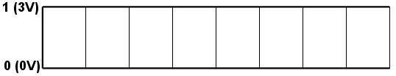

1. Complete the chart for the NOT Gate.

|  |  |
| --- | --- |
| **Symbol** | **Function** |
|  | Reverses the input logic level in a logic gate. |
| **Truth Table** | |
| |  |  | | --- | --- | | **A** | **Y** | | **T** | **F** | | **F** | **T** | | |

1. Complete the chart for the AND Gate.

|  |  |
| --- | --- |
| **Symbol** | **Function** |
|  | To only activate if both inputs are 1 |
| **Truth Table** | |
| |  |  |  | | --- | --- | --- | | **A** | **B** | **Y** | | F | F | F | | T | F | F | | F | T | F | | T | T | T | | |
| **Logic Word Problem (Original Example)** | |
| If I have power and hit the power botton on my computer, it will turn on. | |

1. In your GTT notebook, sketch a circuit diagram that behaves like an AND Gate using a battery, two switches, and an LED output.

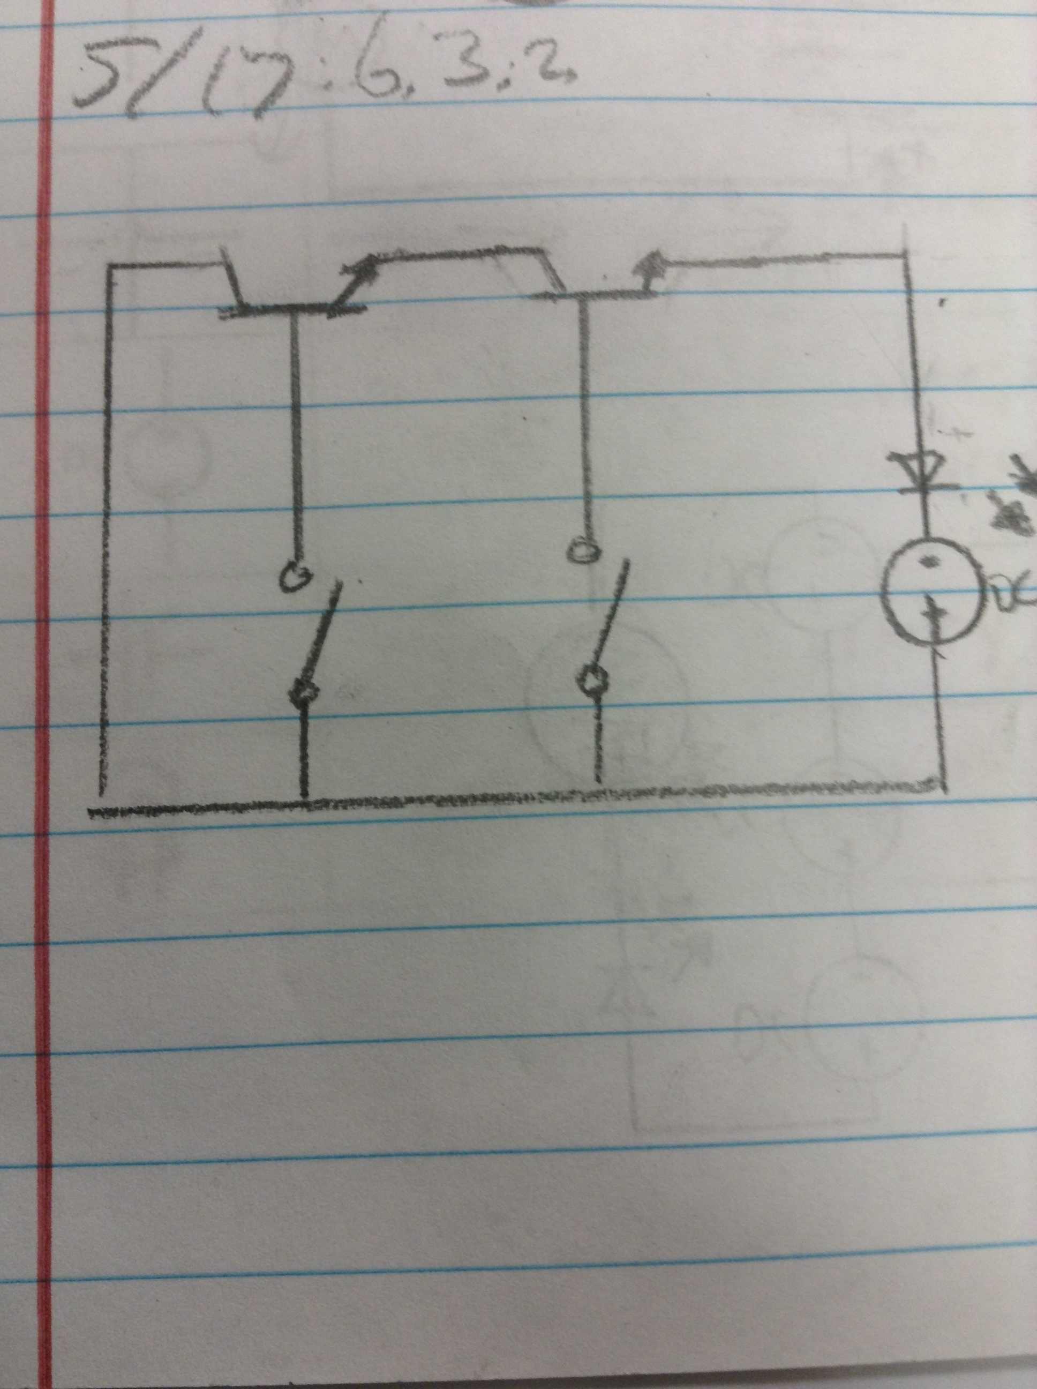

1. Complete the chart for the OR Gate.

|  |  |
| --- | --- |
| **Symbol** | **Function** |
|  | To activate if at least one input is 1 |
| **Truth Table** | |
| |  |  |  | | --- | --- | --- | | **A** | **B** | **Y** | | F | F | F | | T | F | T | | F | T | T | | T | T | T | | |
| **Logic Word Problem (Original Example)** | |
| If I bike or ride the bus, I will get home faster. | |

1. In your GTT notebook, sketch a circuit diagram that behaves like an OR Gate using a battery, two switches, and an LED output.

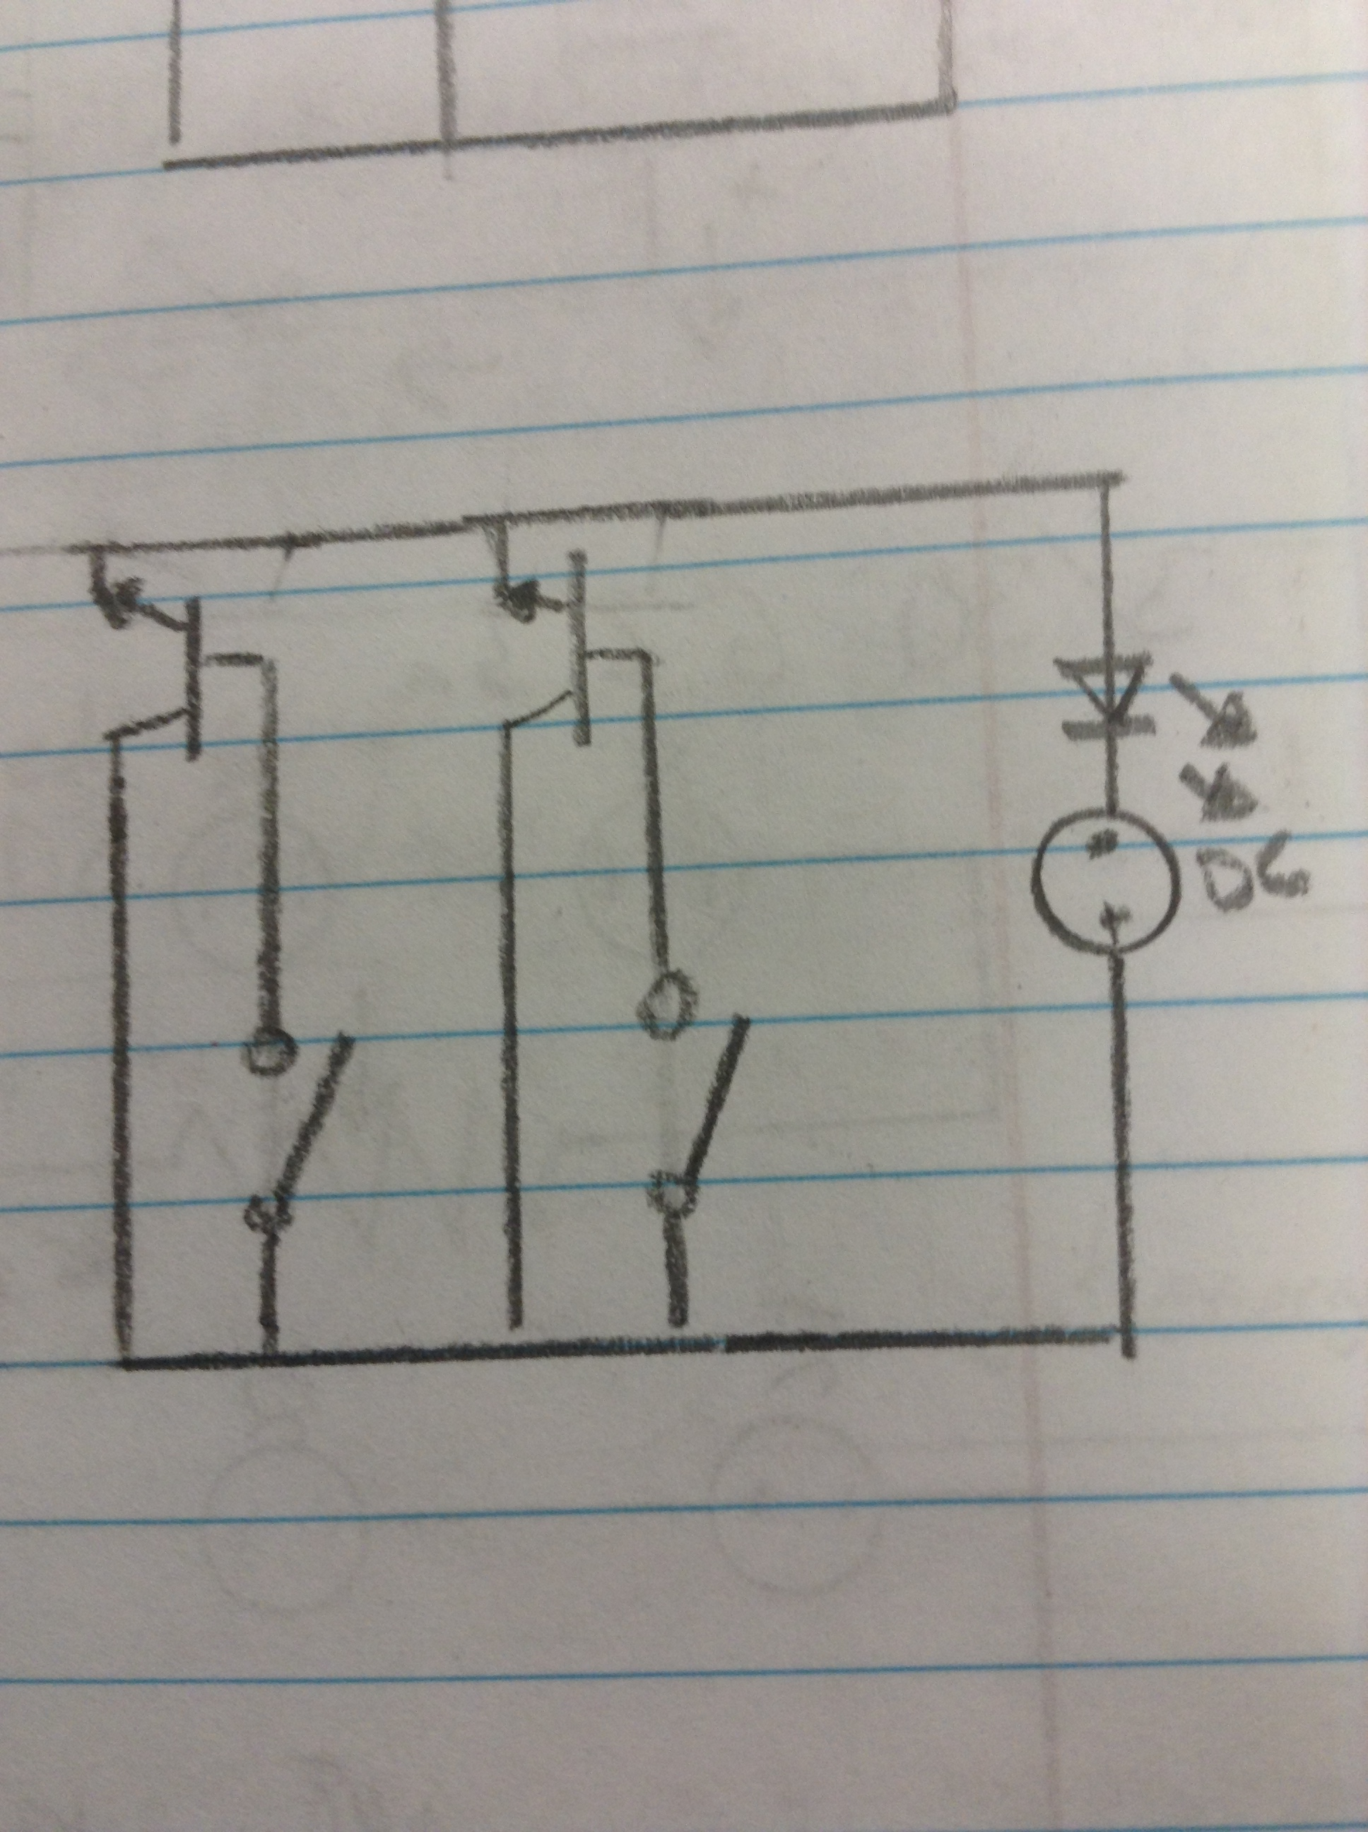

1. Complete the chart for the NAND Gate.

|  |  |
| --- | --- |
| **Symbol** | **Function** |
|  | To deactivate only if both inputs are 1 (Opposite of AND gate). |
| **Truth Table** | |
| |  |  |  | | --- | --- | --- | | **A** | **B** | **Y** | | F | F | T | | T | F | T | | F | T | T | | T | T | F | | |
| **Logic Word Problem (Original Example)** | |
| If it is snowing and night time, I will not drive home. | |

1. Complete the chart for the NOR Gate.

|  |  |
| --- | --- |
| **Symbol** | **Function** |
|  | To deactivate when there is at least one input that is 1 (Opposite of OR gate). |
| **Truth Table** | |
| |  |  |  | | --- | --- | --- | | **A** | **B** | **Y** | | F | F | T | | T | F | F | | F | T | F | | T | T | F | | |
| **Logic Word Problem (Original Example)** | |
| If it is not raining or cold, I will go to the pool. | |

1. Complete the chart for the XOR Gate.

|  |  |
| --- | --- |
| **Symbol** | **Function** |
|  | To activate if only one input is true. |
| **Truth Table** | |
| |  |  |  | | --- | --- | --- | | **A** | **B** | **Y** | | F | F | F | | T | F | T | | F | T | T | | T | T | T | | |
| ***Extra Credit -* Logic Word Problem (Original Example)** | |
| I can go to California or Ney York tomorrow. | |
|  | |

Conclusion

1. Why do computers need logic in order to make decisions?

Computers need logic because they can’t make their own decisions. Logic is their only way to determine a solution.

1. Describe a scenario that you encounter where logic is used to make decisions.

When I go to the store, I have to use logic to determine the best deal. Whether one item that is more expensive, is better than a cheaper item.